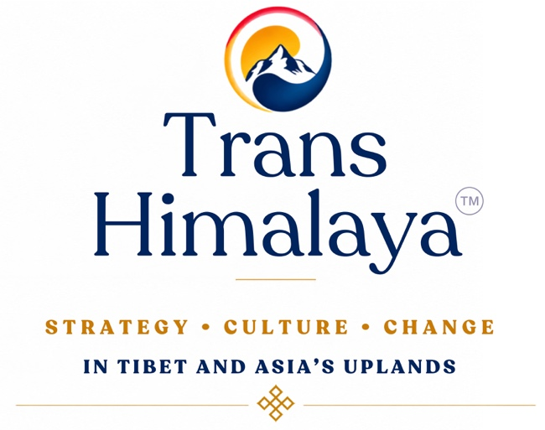
Trans Himalaya is an independent, interdisciplinary research and policy journal examining the forces and transformations shaping Tibet and Asia’s upland regions. Anchored in the Himalayan–Tibetan continuum and extending across Inner and Central Asia, the publication explores the historical, political, economic, cultural, social, and strategic consequences of the People’s Republic of China’s (PRC) control over Tibet, and examines how developments in Tibet—including the policies of the PRC—continue to shape wider regional and international dynamics. By bringing together rigorous scholarship, policy-relevant analysis, and regional voices, Trans Himalaya provides a forum for examining critical issues, emerging challenges, and long-term trends affecting Tibet and Asia’s upland regions. Bridging research and practice, the publication offers a credible platform for informed dialogue on strategy, culture, and change across one of the world’s most consequential yet underexamined regions.
Trans Himalaya – Strategy, Culture and Change in Tibet and Asia’s Uplands is guided by the following principles:
- Intellectual independence and academic integrity
- Analytical depth over advocacy
- Evidence-based argumentation
- Respect for regional diversity and sensitivities
- Constructive engagement with complex issues

EDITOR
Prof. Srikanth Kondapalli, Prof. of Chinese studies, Centre for East Asian Studies, School of International Studies, JNU, and Trustee FNVA

Editorial Board:
Rinzin Namgyal, Researcher, FNVA
O.P. Tandon, Trustee, FNVA
Sonam Topgyal, Researcher, FNVA
Tenzing Dhamdul, Senior Researcher, FNVA

Chairman Governing Council
Ambassador Shyam Saran, President of the India International Centre and Former Foreign Secretary, GoI, and Trustee FNVA

Members of the Governing Council
Bhuchung K. Tsering, International Campaign for Tibet, Washington DC,
Ambassador Dilip Sinha, Former Permanent Representative of India to the United Nations
Dipanjan Roy Chaudhury, Senior Assistant Editor (Foreign Affairs), Economic Times,
Nima Dorjee, Member of the Order of Canada, P.Eng., FEC., FGC (Hon), Calgary, Canada
Ambassador Ranjit Gupta, Trustee FNVA,
Prof. Sriparna Pathak, Professor of China Studies, and the founding Director of the Centre for Northeast Asian Studies at OP Jindal Global University,
Ven. Telo Tulku Rinpoche, Former Representative of His Holiness the Dalai Lama to Mongolia, Russia and the Commonwealth of Independent States, President of Diluva Hutughtu Foundation Mongolia,
Lt. Gen. Vinod Bhatia PVSM, Former Director General of Military Operations (DGMO)

TRANS HIMALAYA OUTLINE
Editor’s Note, Strategic Foresight, Recommendations, Tibet Monitor, In Focus (articles woven around the selected theme of that edition), The Strategic Triangle-India, Tibet and the PRC, Regional and Global Perspectives, (Bhutan, Nepal, Mongolia, Southern Mongolia, East Turkestan, Chinese and other international experts) Youth Voices; Discussion with leaders (interview/s) Dreshay-data and visuals

EXECUTIVE EDITOR
Rebon Catharina Banerjee Dhar, Trustee FNVA

COPYRIGHT EDITOR
Sona Kapila

PUBLISHED BY FNVA

PRINTED BY ACADEMIC FOUNDATION

